Bahria University,

Karachi Campus

LAB EXPERIMENT NO.

______

LIST OF TASKS

|  |  |
| --- | --- |
| TASK NO | OBJECTIVE |
| 1 | Take any integer as input, if the number is greater than 5 print it  If a>5, print a  Else if a=0,then Halt  Else if a<5,then halt |
| 2 | Take two numbers as input and print the larger number. |

Submitted On:

(Date: DD/MM/YY)

TASK # 01: Take any integer as input, if the number is greater than 5 print it

If a>5, print a

Else if a=0,then Halt

Else if a<5,then halt

**INPUT:**

**OUTPUT**:

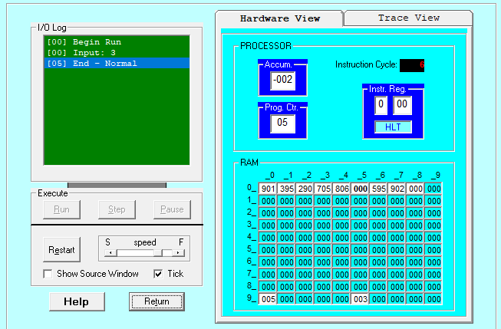

TRACE VIEW

TASK # 02: Take two numbers as input and print the larger number.

**INPUT:**

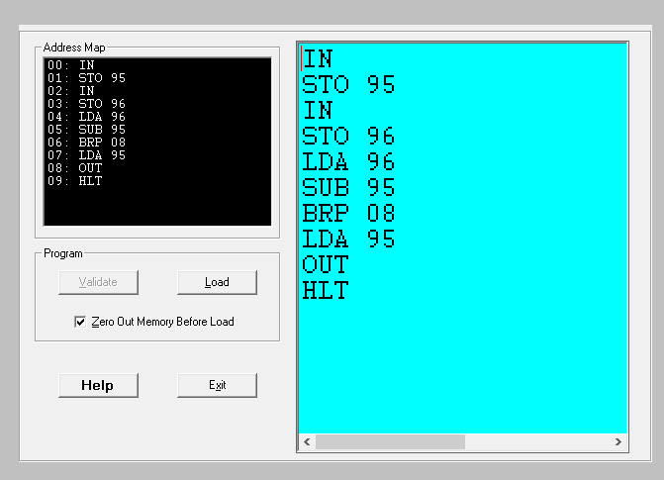

**OUTPUT**:

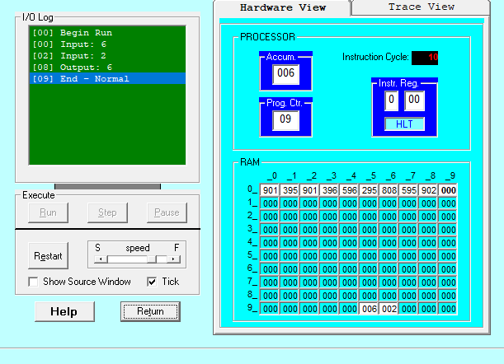

TRACE VIEW

